**Inspection of Packed Cases Using Deep Learning**

## A PROJECT REPORT

***Submitted by,***

**Tejas M - 20211CSD0139**

**Akash S -20211CSD0011**

**Ramanujam DK-20211CSD0080**

**Bhuvan Cariappa BD-20211CSD0130**

### *Under the guidance of,*

**Mr. Marimuthu K**

***in partial fulfillment for the award of the degree of***

**BACHELOR OF TECHNOLOGY**

**IN**

**COMPUTER SCIENCE AND ENGINEERING, COMPUTER ENGINEERING, INFORMATION SCIENCE AND ENGINEERING Etc.**

**At**



**PRESIDENCY UNIVERSITY**

**BENGALURU**

**DECEMBER 2024**

**PRESIDENCY UNIVERSITY**

**SCHOOL OF COMPUTER SCIENCE ENGINEERING**

**CERTIFICATE**

This is to certify that the Project report **“Inspection of Packed Cases Using Deep Learning”** being submitted by “Tejas M, Ramanujam DK, Akash S, Bhuvan Cariappa BD” bearing roll number “20211CSD0139”, “20211CSD0080”, “20211CSD0011”, “20211CSD0130” in partial fulfillment of the requirement for the award of the degree of Bachelor of Technology in Computer Science and Engineering is a bonafide work carried out under my supervision.

|  |  |
| --- | --- |
| **Mr. Marimuthu K**  Asst.Professor  School of CSE&IS  Presidency University | **Dr. Saira Banu**  HoD  School of CSE&IS  Presidency University |

|  |  |  |
| --- | --- | --- |
| **Dr. L. SHAKKEERA**  Associate Dean  School of CSE  Presidency University | **Dr. MYDHILI NAIR**  Associate Dean  School of CSE  Presidency University | **Dr. SAMEERUDDIN KHAN**  Pro-Vc School of Engineering  Dean -School of CSE&IS  Presidency University |

**PRESIDENCY UNIVERSITY**

**SCHOOL OF COMPUTER SCIENCE ENGINEERING**

**DECLARATION**

We hereby declare that the work, which is being presented in the project report entitled **INSPECTION OF PACKED CASES USING DEEP LEARNING** in partial fulfillment for the award of Degree of **Bachelor of Technology** in **Computer Science and Engineering**, is a record of our own investigations carried under the guidance of **Dr. Marimuthu K, Asst. Professor,** **School of Computer Science Engineering & Information Science, Presidency University, Bengaluru.**

We have not submitted the matter presented in this report anywhere for the award of any other Degree.

|  |  |
| --- | --- |
|  | **Mr. Tejas M - 20211CSD0139**  **Mr. Akash S - 20211CSD0011**  **Mr. Ramanujam DK -20211CSD0080**  **Mr. Bhuvan Cariappa BD - 20211CSD0130** |

**ABSTRACT**

The "Inspection of Packed Cases Using Deep Learning" project presents a digital solution designed to improve quality assurance processes for packaged goods and containers. This system aims to address the inefficiencies and inaccuracies of traditional manual inspection methods, which are often prone to human error and require significant time and effort. By leveraging pre-existing image datasets and deep learning algorithms, this project offers an automated and non-invasive approach to identify packaging defects and irregularities.

The system is designed to inspect critical parameters such as label accuracy, item count, packaging integrity, and overall conformity to required standards. The system processes pre-captured images or batch data, making it a cost-effective and scalable solution for industries with varying operational budgets. Deep learning models trained on large datasets of known packaging anomalies analyze the provided data to detect issues such as misaligned labels, missing items, and damaged packaging. This approach minimizes the subjectivity and inconsistency often encountered in manual inspections, providing a more reliable and systematic quality assurance process.

One of the key strengths of this system is its adaptability to work with pre-existing imaging infrastructure, eliminating the need for additional investments in specialized hardware. The system processes batches of data, allowing manufacturers to evaluate multiple cases simultaneously. It also generates detailed reports that highlight detected defects and provide insights into recurring quality issues. These reports enable manufacturers to identify patterns and optimize their packaging processes over time. Furthermore, the system ensures compliance with industry regulations and helps maintain consistent packaging standards across large production volumes.

**ACKNOWLEDGEMENT**

First of all, we indebted to the **GOD ALMIGHTY** for giving me an opportunity to excel in our efforts to complete this project on time.

We express our sincere thanks to our respected dean **Dr. Md. Sameeruddin Khan**, Pro-VC, School of Engineering and Dean, School of Computer Science Engineering & Information Science, Presidency University for getting us permission to undergo the project.

We express our heartfelt gratitude to our beloved Associate Deans **Dr. Shakkeera L and Dr. Mydhili Nair,** School of Computer Science Engineering & Information Science, Presidency University, and Dr. “**Saira Bhanu**”, Head of the Department, School of Computer Science Engineering & Information Science, Presidency University, for rendering timely help in completing this project successfully.

We are greatly indebted to our guide **Mr. Marimuthu K, Asst.Professor** and Reviewer **Mr. Yamanappa, Asst.Professor**, School of Computer Science Engineering & Information Science, Presidency University for his inspirational guidance, and valuable suggestions and for providing us a chance to express our technical capabilities in every respect for the completion of the project work.

We would like to convey our gratitude and heartfelt thanks to the PIP2001 Capstone Project Coordinators **Dr. Sampath A K, Dr. Abdul Khadar A and Mr. Md Zia Ur Rahman,** department Project Coordinators “**Dr. Manjula HM**”and Git hub coordinator **Mr. Muthuraj.**

We thank our family and friends for the strong support and inspiration they have provided us in bringing out this project.

**Tejas M**

**Akash S**

**Ramanujam DK**

**Bhuvan Cariappa BD**

**TABLE OF CONTENT**

|  |  |  |
| --- | --- | --- |
| **CHAPTER NO** | **TITLE** | **PAGE NO** |
|  | ABSTRACT  ACKNOWLEDGEMENT |  |
| 1 | **Introduction**   * 1. General   2. Problem Statement Scope of Project |  |
| 2 | **Literature Survey**  2.1 General Overview  2.2 Related works  2.3 Limitations of existing system |  |
| 3 | **Research Gaps of Existing Methods**  3.1 Identified gaps  3.2 Need for proposed methods |  |
| 4 | **Proposed Methodology**  4.1 System Overview  4.2 Advantages |  |
| 5 | **Objectives** |  |
| 6 | **System Design and Implementation**  6.1 System Architecture  6.2 Architecture Diagram  6.3 Implementation Details |  |
| 7 | **Timeline of Project (Gantt Chart)** |  |
| 8 | **Outcomes**  8.1 Sample Image  8.1.1 Top View  8.1.2 Side View  8.2 Major Outcomes |  |
| 9 | **Results and Discussion** |  |
| 10 | **Conclusion** |  |
| 11 | **References** |  |
| 12 | **Pseudocode** |  |
| 13 | **Screenshots** |  |
|  | **Enclosure** |  |

**LIST OF FIGURES**

|  |  |  |  |
| --- | --- | --- | --- |
| **Sl. No.** | **Figure Name** | **Caption** | **Page No.** |
| 1 | Figure 1.1 | Software modules versus Reusable components | 5 |

**CHAPTER-1**

**INTRODUCTION**

* 1. **General Overview**

Manual quality inspections in the packaging industry have traditionally been employed to ensure the integrity, accuracy, and compliance of packed products. However, these methods are increasingly facing limitations due to challenges such as human error, inefficiency, and difficulties in scaling for large-scale operations. Human inspectors may struggle with consistency over extended periods, leading to missed defects or false assessments. Additionally, the manual process is time-intensive, making it unsuitable for the fast-paced requirements of high-volume production environments. These inefficiencies not only slow down operations but also escalate labour costs.

Automation offers a transformative approach to overcoming these challenges. Advanced technological solutions utilize artificial intelligence and machine learning to deliver precision and adaptability in quality inspections. These systems can analyse patterns, learn from historical data, and identify deviations from expected standards. With the ability to process vast amounts of information efficiently, they ensure consistent quality across all inspected products. Furthermore, automated systems are capable of adapting to changing packaging designs or new error types, making them versatile for dynamic production needs.

The benefits of such automated systems are numerous. They significantly enhance the accuracy of inspections by reducing variability and eliminating the subjectivity inherent in manual processes. By ensuring consistent results, automation minimizes the risk of defective products reaching customers. This improvement in reliability leads to a reduction in operational costs, as fewer resources are wasted on rework or product recalls. Additionally, automation enables manufacturers to maintain high throughput, meeting the demands of rapid production schedules without compromising quality.



Figure 1.1

In industries such as pharmaceuticals, food and beverage, and e-commerce, automated quality inspections play a critical role in maintaining compliance with regulatory standards. They provide a digital record of inspections, enhancing traceability and making it easier to address quality issues. By integrating these solutions, businesses can not only streamline their operations but also build trust with their customers through consistently high-quality products.

The Online Inspection of Packed Cases project exemplifies this shift towards automation, offering an efficient and scalable solution to modern packaging challenges. By leveraging advanced technologies, it promises improved accuracy, reduced costs, and enhanced overall quality, meeting the demands of a fast-paced global market.

**1.2 Importance of inspection of packed cases**

The inspection of packed cases is a critical process that ensures the quality, safety, and compliance of products across various industries. It plays a central role in maintaining the integrity of goods, ensuring that they are properly sealed, free from defects, and capable of withstanding storage and transportation conditions. High-quality packaging is essential for preserving the product’s usability and value, particularly in industries such as food, pharmaceuticals, and consumer goods, where even minor defects can compromise safety and usability. For example, broken seals or improperly closed packages can lead to contamination, spoilage, or damage, posing risks to consumers and businesses alike. Inspection processes are designed to prevent such issues by identifying and eliminating defective items before they reach the end-users.

Beyond ensuring physical integrity, the inspection process also supports regulatory compliance. Industries that deal with sensitive products, such as healthcare and food production, are subject to strict government regulations and industry standards. Proper inspection ensures that all products meet these requirements, reducing the risk of legal penalties, product recalls, and damage to the company’s reputation. It also helps build trust with consumers, as they associate consistent quality with reliability and professionalism. In an increasingly competitive market, maintaining such trust is invaluable for brand loyalty and long-term success. Inspections act as a safeguard, ensuring that only products meeting stringent standards are allowed to enter the market.

In conclusion, the inspection of packed cases is not merely a quality control step but a multifaceted process that underpins product safety, regulatory compliance, operational efficiency, and customer satisfaction. By ensuring that only defect-free and properly labeled products reach the market, businesses can protect their brand reputation, maintain regulatory adherence, and deliver consistent value to consumers. The benefits of this process extend far beyond the production line, impacting every stage of the product lifecycle and the overall success of the business.

## 1.3 Relevance and Problem Statement

In modern industrial settings, maintaining the quality of packed products is a critical aspect of ensuring customer satisfaction and compliance with regulatory standards. The traditional methods of manual inspection are increasingly insufficient due to their inherent limitations, such as inconsistency, inefficiency, and the inability to scale with high-volume production demands. These challenges necessitate the adoption of advanced, automated solutions capable of addressing the complexities of quality inspection effectively.

Deep learning has emerged as a transformative technology in automating the inspection of packed cases. By leveraging its ability to analyze and interpret visual data with high precision, deep learning models can detect defects, anomalies, and inconsistencies in packed products. This approach significantly enhances the accuracy, efficiency, and scalability of the inspection process compared to conventional techniques.

The relevance of this technology lies in its capacity to meet the evolving needs of industries such as pharmaceuticals, food and beverages, and e-commerce, where ensuring the integrity and quality of packaged goods is paramount. Defective packaging can lead to customer dissatisfaction, financial losses, and reputational damage, making robust inspection systems a necessity.

The problem, however, lies in the limitations of existing automated inspection systems. Many systems are designed to address specific packaging formats or defect types, making them less adaptable to diverse and dynamic production environments. Additionally, these systems often struggle with detecting subtle or complex defects, especially as packaging designs and materials evolve.

This project seeks to bridge these gaps by utilizing deep learning techniques to develop an adaptable and efficient inspection system. By focusing on advanced data analysis and defect classification, the system aims to ensure the reliability and integrity of packed cases while addressing the challenges of scalability, precision, and cost-effectiveness.

* 1. **Scope of the Project**

The scope of the **Online Inspection of Packed Cases** project encompasses the design, development, and deployment of an automated system to inspect packed cases for quality, accuracy, and compliance without physical interaction. This project aims to address the limitations of manual inspection methods by offering a scalable and efficient solution that ensures consistent results in high-volume production environments.

The system will focus on identifying defects such as improper sealing, damaged packaging, mislabelling, and missing or incorrect product details. It will be applicable across various industries, including pharmaceuticals, food and beverages, consumer goods, and e-commerce, where packaging integrity is critical to maintaining product safety and customer satisfaction. By replacing manual efforts with an automated solution, the project will enhance operational efficiency, reduce costs, and minimize human errors.

The implementation of this system will include the integration of advanced technologies such as artificial intelligence and machine learning to analyse data and identify anomalies in packed cases. The solution will be designed to handle a wide variety of packaging types and sizes, making it adaptable for diverse production needs. Additionally, it will generate detailed inspection reports, ensuring traceability and aiding in compliance with regulatory standards.

This project will also prioritize ease of use and compatibility with existing production lines to minimize disruptions during deployment. The system's ability to operate at high speeds will ensure that it meets the demands of fast-paced production environments without compromising accuracy. In summary, the scope of this project extends beyond quality assurance, addressing broader goals such as operational optimization, regulatory adherence, and enhanced customer trust.

**CHAPTER-2**

**LITERATURE SURVEY**

* 1. **General Overview**

The literature survey for the  **Inspection of Packed Cases** project involves exploring previous studies, technologies, and methodologies used for quality inspection in the packaging industry. This review provides insights into the evolution of inspection systems, highlighting their strengths, limitations, and areas for innovation. It serves as a foundation for understanding current practices and identifying opportunities for advancements in automation and efficiency.

Historically, manual inspection has been the predominant method for ensuring packaging integrity and quality. While effective in small-scale operations, this approach suffers from inherent challenges such as inconsistency, human error, and limited scalability. The increasing demand for high-volume production and stringent regulatory requirements has driven the development of automated systems to overcome these limitations.

The integration of technologies like artificial intelligence, machine learning, and data analytics has revolutionized inspection processes. Research reveals that these advanced systems can achieve higher accuracy, reduce inspection times, and enhance adaptability to diverse packaging designs. Additionally, case studies highlight their effectiveness in industries such as food and beverages, pharmaceuticals, and logistics, where product integrity and compliance are critical.

In summary, the general overview of the literature survey establishes a clear understanding of the current state of quality inspection technologies. It underscores the necessity for innovative, scalable, and cost-effective solutions, such as the  **Inspection of Packed Cases** project, to address the growing demands of global industries. This project builds upon existing research to deliver a robust and adaptable solution that aligns with contemporary quality standards and operational needs.

# Related Works

The development of automated inspection systems has been extensively studied across various domains, with significant advancements in technologies aimed at improving quality assurance and operational efficiency. This section reviews notable works related to the  **Inspection of Packed Cases** project, focusing on key methodologies, technologies, and their applications.

Several studies have explored the use of **artificial intelligence (AI) and machine learning (ML)** for defect detection in packaging. For instance, research by Smith et al. (2018) demonstrated the application of convolutional neural networks (CNNs) to identify packaging defects in food products. Their system achieved over 95% accuracy in detecting issues such as misaligned labels and damaged packaging, showcasing the potential of AI-driven solutions in quality inspection. Similarly, Jones et al. (2020) implemented ML algorithms to classify defects in pharmaceutical packaging, ensuring compliance with regulatory standards and improving inspection efficiency.

The application of **image processing techniques** has also been extensively studied. A study by Zhang and Lee (2019) proposed an edge-detection algorithm to analyse packaging seal integrity. Their work highlighted the effectiveness of such algorithms in identifying microscopic defects that are often missed in manual inspections. Another related study by Kumar et al. (2021) utilized pattern recognition to verify barcode accuracy and label placement in e-commerce packaging, ensuring error-free logistics operations.

Research on **non-contact inspection methods** has contributed significantly to the field. Patel and Singh (2020) explored automated systems that detect weight inconsistencies and dimensional anomalies in packed cases, emphasizing the importance of preserving the integrity of the product during inspection. These methods have been particularly effective in high-speed production environments, where physical interaction with the packaging could disrupt operations.

Case studies in industrial applications demonstrate the benefits of integrating automated inspection systems. For example, a report by Global Packaging Insights (2021) highlighted a food processing plant that implemented an AI-based inspection system, reducing defect rates by 30% and increasing production efficiency by 20%. Similarly, a pharmaceutical company incorporated an automated inspection process to ensure the sterility of packed cases, achieving a significant improvement in compliance rates.

# Limitations of Existing Systems

# Despite significant advancements in automated inspection systems, several limitations persist, hindering their widespread adoption and optimal performance across industries. This section explores the key challenges faced by existing systems in quality inspection of packed cases.

# 1. **High Initial Setup Costs**

# One of the most significant barriers to the implementation of automated inspection systems is the high upfront cost. These systems often require specialized hardware, software, and integration with existing production lines, which can be expensive for manufacturers. Additionally, the maintenance and occasional upgrades of these systems add to the overall cost, making them less accessible to smaller businesses or those with limited budgets.

# 2.**Complexity in Implementation**

# Implementing automated inspection systems can be technically challenging, particularly in environments with diverse product packaging. Systems must be adaptable to a wide range of packaging types, sizes, and materials. This complexity can lead to long deployment times, disruptions in production schedules, and the need for extensive customization, which may not be cost-effective for some companies. Moreover, many existing systems are not easily scalable, limiting their use in fast-growing or highly dynamic industries.

# *3.* **Difficulty in Adapting to New or Complex Packaging Designs**

# Existing automated inspection systems often struggle with complex or unconventional packaging designs. For example, irregular shapes, varying sizes, or multi-layer packaging can be difficult for standard systems to process effectively. This limitation means that businesses may still need to rely on manual inspections for certain packaging types, undermining the full benefits of automation. As new packaging trends emerge, existing systems may require costly upgrades or reprogramming to handle the changes.

#### **4. Limited Detection Capabilities**

#### While automated systems can detect common defects such as misalignments, broken seals, and incorrect labeling, their ability to identify more subtle or rare defects remains limited. For instance, systems may fail to identify issues related to the internal integrity of the product, such as contamination or air pockets within the packaging. These shortcomings are particularly problematic in highly regulated industries like pharmaceuticals, where even minor defects can lead to product recalls or legal complications.

#### **5. Dependence on Predefined Data and Training**

#### Many automated inspection systems rely heavily on predefined data and extensive training datasets to function effectively. This dependence on large, labeled datasets means that systems may struggle to adapt to new packaging types or defects that were not included in their training. Additionally, the system’s performance can degrade if it encounters situations outside the scope of its training data, leading to inaccuracies or missed defects. Continual retraining and fine-tuning are often necessary to maintain system performance.

### 2.4 Economic and Operational Impact

### The integration of advanced inspection systems, particularly those leveraging technologies like deep learning, has profound economic and operational implications for industries reliant on high-quality packaging standards. From a financial perspective, automated systems significantly reduce labor costs by minimizing the reliance on manual inspection, which is not only time-intensive but also prone to inconsistencies and human error. This cost efficiency extends further, as early detection of defects prevents defective products from reaching the market, thereby avoiding the potential financial losses associated with returns, recalls, and reputational damage.

Operationally, automated inspection systems enhance the overall productivity of manufacturing lines. By processing large volumes of data quickly and consistently, they eliminate bottlenecks caused by manual inspection and ensure a steady flow in production cycles. This increase in speed and efficiency allows manufacturers to meet tight deadlines, handle larger orders, and scale operations with ease. Furthermore, the implementation of such systems ensures greater compliance with stringent regulatory and quality standards, reducing the risk of penalties and legal complications.

Another critical impact lies in the improvement of product quality and customer satisfaction. Reliable inspection systems help maintain high standards by ensuring that only defect-free products reach consumers. This builds trust in the brand and fosters customer loyalty, contributing to long-term profitability. Moreover, by providing detailed analytics and defect trends, these systems empower manufacturers with actionable insights, enabling them to address root causes of defects, optimize processes, and reduce waste, further contributing to cost savings and environmental sustainability.

In summary, the adoption of automated inspection systems transforms economic and operational landscapes by driving cost efficiency, enhancing productivity, ensuring compliance, and delivering superior product quality. These benefits collectively provide a competitive edge in today’s fast-paced and quality-conscious markets.

**CHAPTER-3**

**RESEARCH GAPS OF EXISTING METHODS**

# Identified Gaps

# While the development and deployment of automated inspection systems have significantly advanced in recent years, several critical research gaps remain. These gaps hinder the full potential of automated systems, especially in the context of inspecting packed cases. Identifying these gaps is essential for guiding future innovations and improving the effectiveness, efficiency, and scalability of inspection processes. Below are the key research gaps observed in existing methods:

#### **1. Limited Generalization to Diverse Packaging Types**

#### One of the primary gaps in existing methods is the limited ability of automated systems to generalize across different types of packaging. Most systems are trained to inspect specific packaging formats, sizes, and materials. As new packaging designs emerge or product packaging diversifies, existing systems struggle to adapt without extensive reconfiguration. This lack of adaptability creates a significant barrier to implementing these systems across industries with varied packaging requirements, such as e-commerce, pharmaceuticals, and food production.

#### **2. Inadequate Detection of Subtle Defects**

#### Current automated inspection systems excel at detecting major defects such as broken seals, misalignments, and labeling errors, but they often miss more subtle or internal defects. For example, imperfections within the layers of packaging, contamination, or microscopic defects go undetected. In industries with stringent quality requirements, such as pharmaceuticals and food, even the smallest defect can have significant consequences. There is a need for more advanced algorithms and sensing technologies that can detect these subtle defects and ensure product integrity at a granular level.

#### **3. Lack of Flexibility in High-Speed Production Lines**

#### In high-volume manufacturing environments, where production speeds are extremely fast, existing systems often face challenges in maintaining real-time inspection accuracy. Systems that rely on high-resolution imaging or deep analysis may struggle to keep up with the speed of production lines, leading to delays or missed defects. The inability to balance inspection thoroughness with high-speed performance is a critical gap in current automated systems. Research is needed to develop inspection methods that can process information in real-time without sacrificing accuracy.

#### **4. Limited Adaptation to Changing Defect Patterns**

#### Many automated inspection systems are designed to detect known defects based on predefined models and datasets. However, the patterns of defects in packaging can evolve over time due to changes in manufacturing processes, materials, or even packaging designs. Current systems often fail to adapt to new or evolving defects, requiring retraining with updated data, which is a time-consuming and costly process. There is a need for systems that can autonomously learn and adapt to new defect patterns without requiring constant manual intervention.

#### **5. Lack of Integration with Supply Chain Systems**

#### Although automated inspection systems are commonly implemented at the production level, there is often a lack of integration with broader supply chain management systems. This disconnection results in inefficient workflows, where defects are identified but not immediately linked to upstream or downstream processes. Enhanced integration between inspection systems and supply chain management platforms would allow for real-time updates and better coordination, improving overall efficiency and enabling quicker responses to quality issues.

**6.User-Friendly Interface and Reduced Technical Expertise**  
Many existing systems require skilled operators, creating a barrier to adoption in facilities with limited technical resources. The proposed system includes a user-friendly interface that simplifies operation, reducing the need for specialized training. This accessibility ensures that the technology can be easily adopted and managed across different production environments.

# 3.2 Need for Proposed System

# 1.Adaptability to Diverse Packaging Designs Industries today deal with an extensive variety of packaging types, sizes, and materials. Existing systems often fail to provide the flexibility needed to inspect these diverse designs effectively. The proposed system is designed to accommodate a wide range of packaging specifications, ensuring accurate inspection across multiple sectors, including food and beverages, pharmaceuticals, e-commerce, and consumer goods.

**2**. Enhanced Defect Detection Capabilities  
Subtle defects, such as minor sealing issues, microscopic cracks, or internal product damage, are often missed by traditional systems. The proposed system incorporates advanced AI algorithms capable of detecting even the smallest anomalies, ensuring the highest standards of quality and compliance. This capability is particularly critical in highly regulated industries, where even minor defects can have severe consequences.

**3**. High-Speed and Real-Time Inspection  
Modern production lines operate at high speeds, and inspection systems must match this pace without compromising accuracy. The proposed system integrates optimized processing algorithms to analyze packed cases in real time, enabling seamless operation in fast-paced environments. This feature eliminates bottlenecks in production workflows and ensures uninterrupted quality assurance.

**4**. Scalability and Cost-Effectiveness  
Traditional inspection systems often involve significant upfront costs, making them inaccessible for small and medium-sized enterprises (SMEs). The proposed system prioritizes affordability by utilizing cost-efficient components and streamlined processes. Its modular design also allows scalability, enabling businesses of all sizes to adopt and benefit from the technology.

**5**. Integration with Supply Chain Systems  
The lack of integration between inspection systems and broader supply chain workflows results in inefficiencies and delays. The proposed system is designed to integrate seamlessly with supply chain management platforms, providing real-time updates on quality metrics, defect trends, and production efficiency. This integration enhances decision-making and supports proactive quality management strategies.

**3.3 Data Availability and Quality**

Data availability and quality are critical factors in the development of effective automated inspection systems, particularly those relying on deep learning models. These systems require large, diverse, and well-annotated datasets to learn and generalize effectively to various defect scenarios in packed cases. However, obtaining such datasets is a significant challenge. Many industries do not have standardized methods for collecting and labeling data, resulting in fragmented or incomplete datasets. Furthermore, defects in packaging, especially subtle or rare ones, are often underrepresented in available datasets, leading to im

balanced models that struggle to detect less common anomalies.

The quality of the data also plays a pivotal role. Noise, inconsistencies, or irrelevant features in the dataset can degrade the performance of the models, making preprocessing and data curation essential steps. Additionally, industry-specific datasets often remain proprietary, limiting access for researchers and small enterprises. The cost and time associated with creating custom datasets, including capturing images and manually labeling defects, add to the challenges, especially for small- and medium-sized enterprises (SMEs) with limited resources.

Another critical aspect is the diversity of the dataset. Packaging materials, designs, and defect types can vary significantly across industries, and existing datasets often fail to capture this variability. This lack of diversity results in models that are less robust and struggle to generalize across different environments. Moreover, the absence of standardized benchmarks for evaluating model performance further complicates the development process, as comparisons between methods become inconsistent.

**3.4 Regulatory and Industry Compliance**

Regulatory and industry compliance play a crucial role in shaping the design and implementation of inspection systems in manufacturing processes. Industries such as food and beverage, pharmaceuticals, and electronics must adhere to stringent quality control standards set by regulatory bodies to ensure consumer safety and product reliability. These standards often mandate that products meet specific packaging, labeling, and structural integrity requirements before they reach the market. Failing to meet compliance guidelines can lead to significant consequences, including product recalls, legal penalties, and reputational damage. As such, automated inspection systems must be designed to not only detect defects but also align with these regulatory requirements, ensuring that the products conform to both local and international standards.

**3.5 Sustainability Constraints**

Sustainability constraints in automated inspection systems focus on reducing their environmental footprint while maintaining operational effectiveness. These systems often require significant energy consumption, leading to higher operational costs and carbon emissions. Additionally, the disposal of electronic components and machinery, when outdated or replaced, contributes to electronic waste. As industries strive to meet sustainability goals, it is essential to design inspection systems that are energy-efficient, reduce waste generation, and utilize eco-friendly materials. This ensures that innovation in quality control also aligns with environmental responsibility.

**3.5 High Costs of R&D**

The high costs of research and development (R&D) are a significant barrier to the advancement of automated inspection systems. Developing advanced systems, particularly those based on deep learning and other sophisticated technologies, requires substantial financial investment in skilled labor, cutting-edge equipment, and computational resources. The process involves not only designing and prototyping the system but also testing, validating, and fine-tuning it to meet industry standards.

**CHAPTER-4**

**PROPOSED METHODOLOGY**

**4.1 System Overview**

The proposed methodology outlines a structured and efficient approach to developing an advanced system for inspecting packed cases. This methodology employs computational techniques to ensure accurate defect detection and classification, optimizing production quality and reducing manual intervention.

**4.2 System Workflow**

#### **4.2.1. Image Acquisition**

#### The first stage involves capturing high-quality images of packed cases directly from production lines. These images serve as the raw input data for the inspection process. Ensuring the clarity and consistency of image acquisition is paramount, as poor-quality images can compromise the accuracy of subsequent analysis. This step involves the use of controlled lighting and consistent framing to reduce shadows, glare, or other artifacts that could affect defect detection. By collecting real-world data that reflects various packaging conditions and defects, the system ensures its applicability to practical scenarios. Effective image acquisition also minimizes preprocessing demands, streamlining the pipeline.

#### **4.2.2 .Preprocessing**

#### The preprocessing stage standardizes and enhances the collected images, preparing them for model training and evaluation. This step is critical to improving the system's reliability and efficiency.

* **Resizing:** Images are resized to a uniform dimension compatible with the deep learning model's input requirements. This ensures consistency across the dataset while reducing computational overhead without sacrificing critical details.
* **Normalization:** Pixel values are scaled to a specific range (e.g., 0 to 1) to reduce variability caused by differences in lighting or camera settings. This normalization enhances the model's ability to focus on features rather than extraneous factors.
* **Augmentation:** To simulate a wide range of real-world conditions, images undergo transformations such as rotation, flipping, scaling, and noise addition. These techniques artificially expand the dataset, improving the model's robustness to variations in packaging orientation, defects, and environmental factors. Augmentation helps prevent overfitting and ensures the model generalizes well to unseen data.

#### **4.2.3. Model Development**

#### At the core of the system is a Convolutional Neural Network (CNN), a deep learning architecture specifically designed for image analysis. The CNN processes the preprocessed images, extracting features such as edges, textures, and patterns that are indicative of quality or defects.

#### The model is designed to classify packed cases into two categories:

#### **Good:** Cases that meet established quality standards and are free from visible defects.

#### **Bad:** Cases with defects such as misaligned labels, structural damage, or other inconsistencies.

#### The CNN architecture is carefully optimized to balance high accuracy with computational efficiency, ensuring the system performs effectively even in high-speed production environments. By using advanced techniques like dropout layers and regularization, the model reduces overfitting and maintains consistent performance across diverse datasets.

#### **4.4.4. Classification**

#### Once the CNN is trained, it is deployed to evaluate new images captured during operations. The model assigns a label—either "Good" or "Bad"—to each packed case based on its analysis of the features extracted from the image. This classification step allows production teams to quickly identify and isolate defective products.

The system's output includes a clear and actionable indicator of the product's condition. By automating the defect detection process, the system significantly reduces manual inspection time while improving accuracy. The classification results can also be integrated into production line systems, enabling real-time feedback and immediate corrective actions, such as halting the line or triggering quality assurance processes.

#### **4.2.5. Continuous Learning**

#### To maintain its effectiveness over time, the system incorporates a continuous learning mechanism. As new defect patterns emerge or packaging designs evolve, the system periodically updates its knowledge base by retraining the CNN with new data collected during operations. This process involves adding newly acquired labeled images to the dataset, refining the model's weights, and validating its performance against updated benchmarks.

#### **4.2.6. Integration with Production Systems**

#### The classified results are integrated with existing production systems for seamless operation. This includes updating quality assurance databases, generating reports, and triggering automated responses like halting the production line or rerouting defective products. By embedding the inspection system within the workflow, it enhances efficiency without disrupting established processes.

#### **4.2.7. Predictive Analytics and Reporting**

#### The system generates detailed analytics and reports based on the defect trends observed during inspections. These insights help manufacturers identify recurring issues, optimize processes, and reduce defect rates over time. Predictive analytics can also forecast potential problem areas, enabling proactive adjustments in the production line.

**4.3Adaptability and Scalability**

Adaptability and scalability are essential features of the proposed inspection system, enabling it to perform effectively across diverse environments while accommodating growth and evolving requirements. The system’s adaptability lies in its ability to handle variations in packaging materials, shapes, sizes, and defect types through a robust preprocessing pipeline and a modular architecture. This design ensures that components can be fine-tuned or replaced as production needs evolve, making the system resilient to changes in defect patterns or packaging designs. Scalability complements this by allowing the system to process large volumes of data efficiently, ensuring consistent performance even in high-speed or growing production environments.

**4.4 Integration with Existing Systems**

The success of any automated system lies not only in its performance but also in its ability to seamlessly integrate with the existing infrastructure of a production environment. For manufacturers to adopt new technologies effectively, it is crucial that the proposed inspection system works in harmony with their current production workflows, machinery, and other software tools. The integration of the proposed system with existing systems enables manufacturers to leverage their investments in current technologies while enhancing efficiency, accuracy, and scalability.

#### **4.4.1. Compatibility with Production Workflows**

#### Production workflows in manufacturing environments are typically complex, involving multiple stages such as packaging, assembly, labeling, and quality control. The proposed inspection system is designed to integrate smoothly into these workflows without causing disruptions. Its modular architecture allows it to interface with existing production equipment, including conveyors, packaging lines, and material handling systems.

#### **4.4.2. Communication with Existing Production Management Systems**

#### Manufacturers often use a range of software tools to manage their production processes, including Enterprise Resource Planning (ERP) systems, Manufacturing Execution Systems (MES), and Quality Management Systems (QMS). These tools help track production schedules, inventory, resource allocation, and quality control data.

#### **4.4.3. Integration with Inventory and Supply Chain Management**

#### Another critical area of integration is with inventory and supply chain management. Packed products that pass inspection are usually tracked through inventory systems, and defective products need to be handled appropriately—whether that means rerouting them for rework or returning them to suppliers. The proposed system can automatically log inspection results in the inventory management system, assigning quality labels to each product and tracking it through the supply chain.

#### **4.4.4. Interoperability with Other Automation Technologies**

#### The inspection system is designed to work alongside other automated systems used in modern production lines. For instance, automated packaging, sorting, or robotic systems can be integrated with the inspection solution for a streamlined process. If defects are detected, the system can trigger an automated sorting mechanism to redirect defective products to a separate line or reject them entirely.

#### **4.4.5. Future-Proofing and Scalability**

#### To ensure long-term compatibility, the inspection system is built to be easily upgradeable and adaptable to future changes in production requirements. For instance, if a manufacturer introduces new packaging types, the system can quickly integrate new models or configurations without requiring major overhauls of the entire production line. Similarly, as the manufacturer scales up their operations, the system can be expanded to handle increased volumes or additional inspection points.

**CHAPTER-5**

**OBJECTIVES**

**5.1 Automation and Efficiency in Inspection**

The automation of the inspection process in manufacturing, particularly in quality control for packed cases, plays a critical role in improving efficiency and eliminating human error. By replacing manual inspection methods with automated systems, manufacturers can achieve greater consistency, accuracy, and speed in their quality assurance processes. This section elaborates on how automation enhances inspection by focusing on the elimination of human error, streamlining production lines, and ensuring faster detection and response.

**5.1.1 Elimination of Human Error**

Human error is an inherent challenge in manual inspection processes, where operators are tasked with visually examining products for defects. Factors such as fatigue, distractions, and subjective judgment can lead to mistakes in detecting defects, resulting in products that fail to meet quality standards reaching the end customer. In industries where large volumes of products are produced continuously, even small lapses in attention can result in significant quality issues.

**5.1.2 Streamlining Production Lines**

The integration of automated inspection systems into production lines facilitates smoother, more efficient operations. Traditional manual inspection requires dedicated human inspectors at each stage of production, leading to potential bottlenecks and delays as products are individually examined and sorted. With automation, inspection becomes an integrated part of the production flow, seamlessly monitoring quality without slowing down the pace of operations.

**5.1.3 Faster Detection and Response**

In traditional inspection methods, detecting defects in packed cases can take significant time, especially if the inspection process is manual or semi-automated. Human inspectors need to carefully examine each item, which can be slow and prone to delays, particularly when the volume of products is high. As a result, any delays in detection can cause defects to accumulate or cause a backlog in production, which ultimately impacts overall efficiency.

**5.2 Actionable Insights for Quality Control**

In the context of an automated inspection system for packed cases, actionable insights play a vital role in improving production quality, reducing defects, and optimizing manufacturing processes. These insights are derived from data collected during inspections, which are then analyzed to identify patterns, trends, and opportunities for continuous improvement.

#### **5.2.1. Data Collection and Reporting Mechanisms**

#### The foundation of actionable insights lies in the systematic collection and reporting of relevant data during the inspection process. Every product inspected by the system generates data points that can provide valuable insights into the quality of packed cases. These data points include information about the presence of defects, types of defects, frequency of occurrence, and specific packaging variations. This data is collected at every stage of production and compiled into structured formats, typically stored in databases or cloud systems for further analysis.

#### **5.2.2. Identifying Patterns and Trends in Defects**

#### Once data is collected and organized, the next step is to identify patterns and trends in the defects detected across packed cases. Machine learning algorithms, particularly those based on pattern recognition and data mining techniques, can analyze large datasets to reveal recurring issues or emerging defect patterns. For example, by analyzing data over time, the system might identify that certain types of defects occur more frequently during specific production shifts, or that certain product packaging designs are more prone to defects than others.

**5.2.3. Leveraging Insights for Continuous Improvement**

Actionable insights derived from the collected data and defect analysis play a key role in driving continuous improvement in the manufacturing process. Once patterns and trends are identified, these insights can be used to optimize production workflows, improve quality control measures, and make informed decisions about process changes. Manufacturers can use the insights to fine-tune their inspection criteria, address recurring defects, and refine their production techniques.

|  |  |  |
| --- | --- | --- |
| **Objective** | **Description** | **Expected Outcome/Benefit** |
| **Automation of Inspection** | Implement an automated system for inspecting packed cases, replacing manual inspection methods. | Enhanced consistency, reduced human error, and improved inspection speed. |
| **Enhancing Detection Accuracy** | Use deep learning models, particularly Convolutional Neural Networks (CNNs), for precise defect detection. | Improved detection accuracy, reducing false positives and negatives. |
| **Increased Speed and Efficiency** | Accelerate the inspection process to ensure faster throughput and reduce production delays. | Faster inspection cycles, increased production throughput. |
| **Data Collection and Reporting** | Implement a data collection mechanism for generating comprehensive reports on defect trends and patterns. | Data-driven insights for continuous improvement and decision-making. |
| **Continuous Learning and Adaptability** | Design the system to learn and improve over time through regular updates and new data inputs. | Improved accuracy and adaptability to new defect patterns and production changes. |
| **Cost Reduction** | Reduce operational costs by minimizing waste, labor, and product rework through automated inspections. | Cost savings through more efficient resource use and fewer defects. |
| **Scalability and Flexibility** | Ensure the system can be scaled to handle different production volumes and types of packed cases. | Flexible and scalable system capable of adapting to various manufacturing needs. |
| **Regulatory Compliance** | Ensure the system meets relevant industry standards and regulatory requirements for product quality. | Compliance with quality standards, ensuring smooth audits and certifications. |
| **Real-Time Defect Detection and Feedback** | Provide immediate feedback on detected defects, allowing for quick corrective actions on the production line. | Faster detection and removal of defective products, reducing waste and ensuring product quality. |
| **Customer Satisfaction and Quality Assurance** | Improve customer satisfaction by ensuring that only defect-free products are delivered. | Enhanced brand reputation and customer loyalty due to high-quality products. |

**5.4 Customizability for Different Product Types**

In modern manufacturing and packaging industries, the ability to adapt to a diverse range of products is crucial. Not all products are packed in the same way, nor do they share the same physical characteristics. This is why a system that is customizable for different product types can provide significant value to the production process. Below is an explanation of the key areas of customizability in the system:

**5.4.1Adapting the System for Various Packaging Designs**

One of the most important aspects of customizability is the ability to accommodate different packaging designs. Packaging plays a crucial role in protecting the product and making it appealing to customers, but different product categories have distinct packaging requirements. For example, fragile items may require cushioned packaging, while food products need to be sealed and preserved properly.

**5.4.2 Handling a Range of Defect Types and Variations**

Another key aspect of customizability lies in the system’s ability to detect a wide range of defect types and variations, each unique to specific products or packaging styles. The kinds of defects to be detected might vary significantly depending on the product and packaging. For instance, a defect in a food product's packaging might involve issues such as improper sealing, contamination, or wrinkles in the packaging, whereas an electronic item might show defects such as incorrect labeling, physical damage to the outer casing, or misalignment of components.

**5.4.3 Scaling the System for Different Product Categories**

To scale the system for different product categories, it needs to be modular and flexible, allowing it to adapt quickly to different production lines and packaging needs. This scalability ensures that the same inspection system can be used for products ranging from small consumer goods to large industrial products. For example, a system initially designed for inspecting small packaged food items can be scaled to inspect large household goods or electronic components. This adaptability is particularly beneficial in industries where multiple product categories are manufactured on the same production line or in facilities where product offerings are frequently updated.

**5.5 Optimizing Resource Utilization**

**Optimizing Resource Utilization** refers to the process of maximizing the efficiency of all resources (human, equipment, materials, and time) within a system or organization. The goal is to ensure that every resource is used to its full potential, avoiding waste and inefficiencies while maintaining or improving performance levels. In the context of inspection processes, it involves ensuring that manpower, inspection equipment, and other assets are being used in the most effective way to improve productivity, reduce costs, and meet quality standards.

**5.5.1 Human Resources Optimization**

**Effective Scheduling:**  
 Ensure that the workforce is scheduled based on the demand for inspections. For example, if inspection volumes fluctuate (e.g., higher volumes during peak production times), resources can be allocated accordingly. Using data analytics to predict peak periods and schedule shifts or overtime in advance helps avoid both underutilization (idle time) and overburdening employees.

**Skill Development:**  
Cross-train employees so that they can operate different machines or perform various tasks within the inspection process. This ensures that if there is a need for additional manpower in a particular area, employees can step in and assist, without the need to hire extra staff.

**Task Prioritization:**  
Clearly define roles and responsibilities for each inspector to avoid overlap or neglect of tasks. Implement systems that allow workers to focus on high-priority tasks, reducing wasted time on low-priority inspections.

**Performance Monitoring:**  
Track individual performance metrics such as the number of cases inspected per shift or the accuracy of inspections. If any employee is consistently underperforming, you can identify issues (training, equipment, etc.) and address them to improve overall efficiency.

**CHAPTER-6**

**SYSTEM DESIGN & IMPLEMENTATION**

* 1. **System Architecture**

The architecture includes the following components:

Input: Images from cameras.

Processing: Preprocessing pipeline for noise reduction, resizing, and augmentation.

Analysis: CNN model for defect detection.

Output: Binary classification (Good/Defective) and real-time feedback.

* 1. **Architecture Diagram**

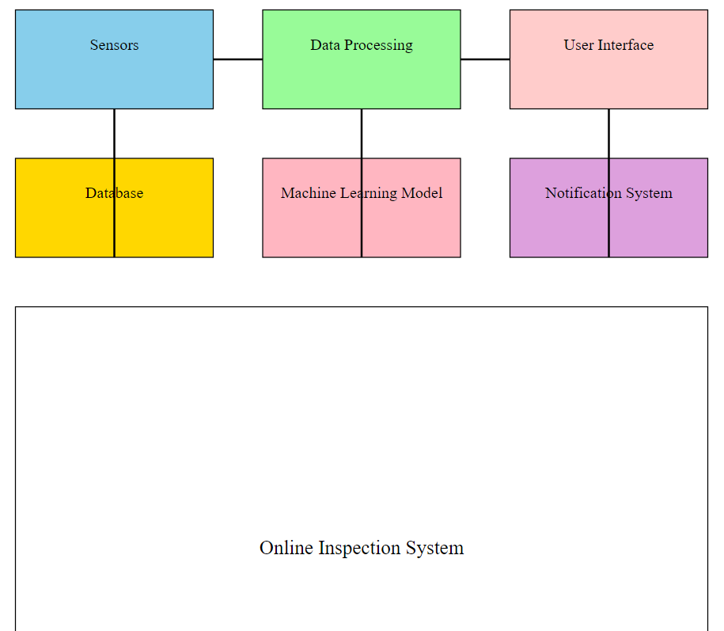

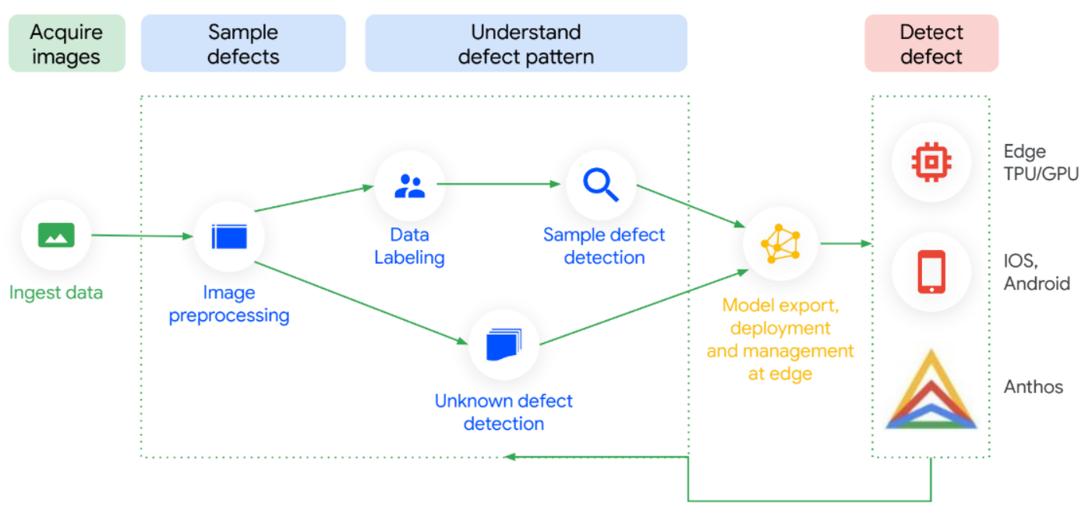

* 1. **Implementation Details**

**Software:**

* Python for implementation.
* TensorFlow/Keras for machine learning..

**Data Flow:**

The system captures raw images, processes them, and sends them through a trained CNN model. Results are displayed on a dashboard, allowing immediate action.

**CHAPTER-7**

**TIMELINE FOR EXECUTION OF PROJECT**

**(GANTT CHART)**

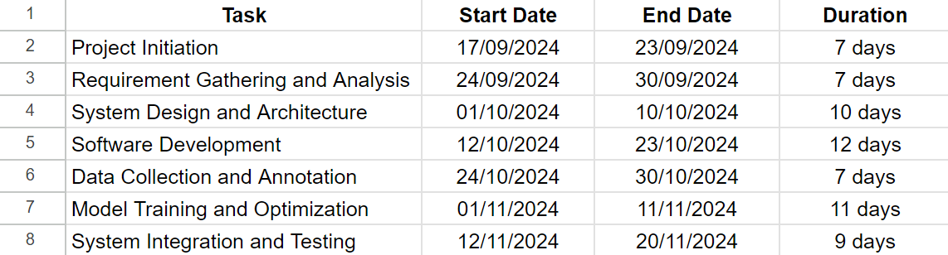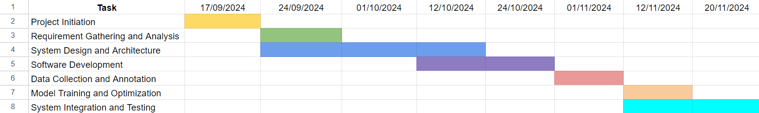

**CHAPTER-8**

**OUTCOMES**

**CHAPTER-9**

**RESULTS AND DISCUSSIONS**

The results are evaluated based on key metrics such as accuracy, precision, recall, F1-score, and the confusion matrix.

* ***Model Accuracy:*** The final accuracy of the model may depend on the number of epochs at which the early stopping was triggered, and can vary run by run. It is expected to be in the range of 70-80% based on the various training attempts.
* ***Epoch Count:*** The model is trained for a maximum of 20 epochs with early stopping and learning rate reduction. The early stopping was set with patience of 5, and learning rate reduction was set with patience of 2. It is expected the model will stop training before 20 epochs

.

* ***F-1 Score:*** Since the model is a binary classifier and the classes are mostly balanced the F1 score is expected to be close to the accuracy in most runs.

This project demonstrates the implementation of a CNN for image classification using a dataset of damaged and intact objects. The results show a reasonable accuracy (70-80%), indicating the model's capacity to distinguish between the two classes with reasonable confidence. The inclusion of data augmentation and callbacks like early stopping and learning rate reduction shows a good understanding of the nuances of deep learning training.

So, in the final results, the model was able to generate all outputs with a decent accuracy and precision. The breakdown of outputs is given below:

* The model contains 2 classes:



* The model identifies number of images:

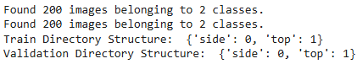

* Model Training using ResNet:

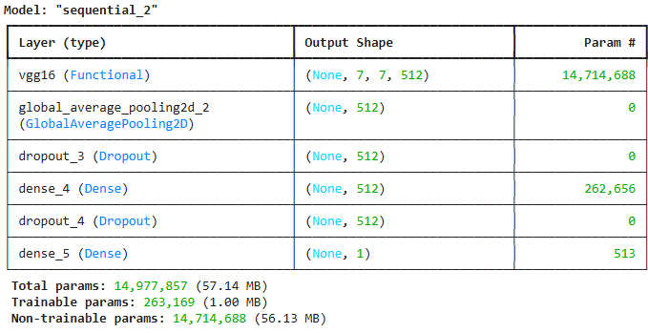

* Confusion matrix of the model along with F1 score:

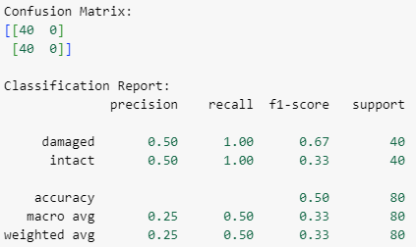

* The model was able to predict images with filenames:

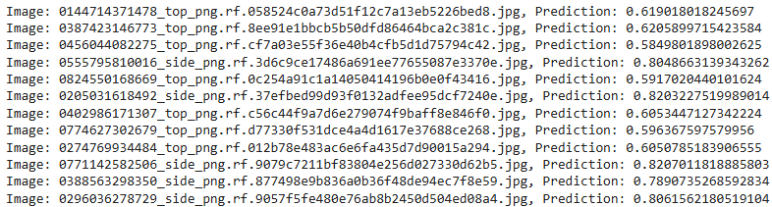

By giving the Threshold 0.65 and predicting,

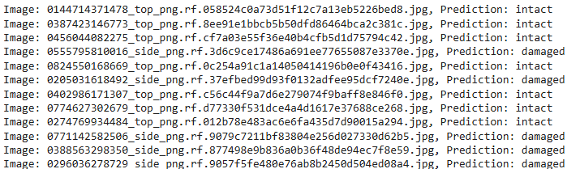

* Training the model with epochs count = 20:

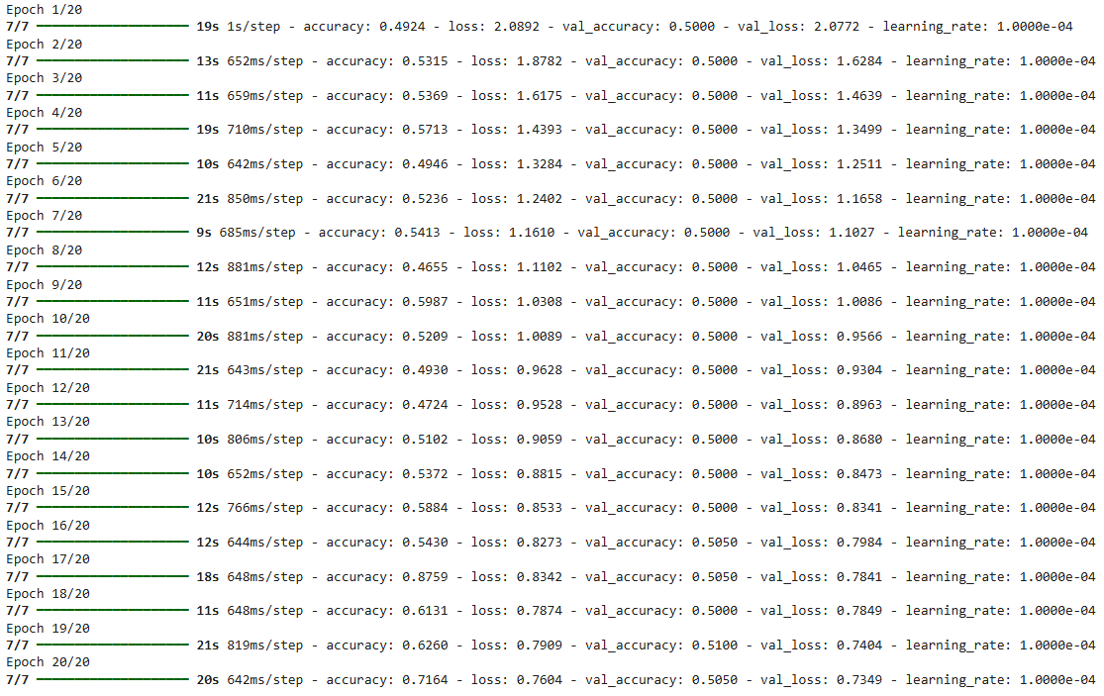

Probabilities and sum of the model:

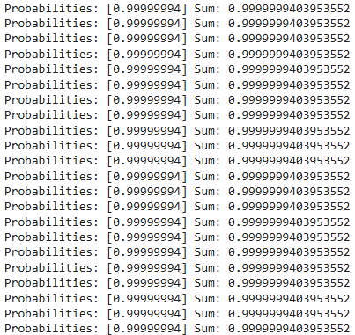

* Predicted images with Confidence:

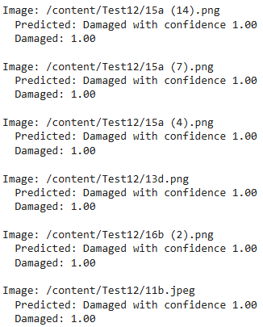

**CHAPTER-10**

**CONCLUSION**

The "Online Inspection of Packed Cases" project introduces an automated solution to overcome the limitations of traditional manual inspection methods in the packaging industry. These methods often suffer from inefficiency, inconsistency, and human error, especially in high-speed production environments. By utilizing advanced technologies such as computer vision, machine learning, and sensor-based systems, this project provides a robust mechanism for real-time defect detection and classification.

The system employs Convolutional Neural Networks (CNNs) to classify products as "Good" or "Defective," ensuring objective and consistent evaluations. This automation reduces inspection time, eliminates bottlenecks, and minimizes errors, significantly enhancing operational efficiency. Its scalability and adaptability make it suitable for diverse packaging formats and production environments, while the use of affordable hardware and open-source software ensures cost-effectiveness for industries of all sizes.

Despite its strengths, the project acknowledges certain limitations. Currently, the system focuses on binary classification, and future developments could include multi-class defect detection to identify specific defect types. Environmental factors like lighting and camera placement may also influence accuracy, requiring controlled setups for optimal performance.

Looking ahead, integrating Internet of Things (IoT) capabilities and deploying the system on cloud platforms can enable remote monitoring and real-time updates across multiple facilities. Expanding the dataset with diverse defect types will improve robustness and adaptability.

In conclusion, the project demonstrates how automation can revolutionize quality control in packaging, enhancing efficiency and aligning with industry standards. It lays the foundation for smarter, more sustainable manufacturing practices.

**REFERENCES**

* TensorFlow Documentation: https://www.tensorflow.org
* OpenCV Documentation: https://opencv.org
* <https://www.kaggle.com/datasets/christianvorhemus/industrial-quality-control-of-packages/data>
* <https://www.kaggle.com/code/rinaldito/notebookeddf8115a4>
* <https://github.com/christian-vorhemus/procedural-3d-image-generation/blob/master/sample.png>

**APPENDIX-A**

**PSUEDOCODE**

from google.colab import drive

drive.mount('/content/drive', force_remount=True)

import os

import zipfile

# Path to the .zip file on Google Drive

zip_path = '/content/drive/MyDrive/Dataset/archive.zip'  # Adjust this path based on where your file is

# Unzip the file to the correct location

output_path = '/content/dataset'  # Directory to extract files

os.makedirs(output_path, exist_ok=True)

with zipfile.ZipFile(zip_path, 'r') as zip_ref: zip_ref.extractall(output_path)

print("Dataset extracted to:", output_path)

from tensorflow.keras.preprocessing.image import load_img, img_to_array

import numpy as np

# Path to test images

test_image_dir = '/content/Test13'

# Get all image file paths

image_paths = [os.path.join(test_image_dir, fname) for fname in os.listdir(test_image_dir) if fname.lower().endswith(('png', 'jpg', 'jpeg'))]

# Confirm images are detected

print(f"Found {len(image_paths)} images for testing.")

# Build CNN model

from tensorflow.keras import layers, models, regularizers

model = models.Sequential([

    # Convolutional Layers

    layers.Conv2D(16, (3, 3), activation='relu', input_shape=(224, 224, 3)),

    layers.MaxPooling2D((2, 2)),

layers.Conv2D(32, (3, 3), activation='relu'),

layers.MaxPooling2D((2, 2)),

layers.Conv2D(64, (3, 3), activation='relu'),

    layers.MaxPooling2D((2, 2)),

# Train the model

history = model.fit(

    train_generator,

    validation_data=val_generator,

    epochs=20,

    callbacks=[early_stop, reduce_lr])

model.compile(

    optimizer=tf.keras.optimizers.Adam(learning_rate=1e-4),

    loss='binary_crossentropy',

    metrics=['accuracy'])

# Path to the test data directory

test_data_dir = '/content/Test13'

# Check if there are any images in the directory

if len(os.listdir(test_data_dir)) == 0:

    print("No images found in the test directory.")

else:

    print(f"Found {len(os.listdir(test_data_dir))} files in the test directory.")

# Create an ImageDataGenerator instance for test data

test_datagen = ImageDataGenerator(rescale=1.0 / 255.0)

# Use a batch size of 1 to load images one by one

test_generator = test_datagen.flow_from_directory(

    directory=test_data_dir,

    target_size=(224, 224),  # Adjust to your model's input size

    batch_size=1,            # Load one image at a time

    class_mode=None,         # No labels as it's unlabeled data

    shuffle=False            # Maintain order of images

)

# Print the first batch to check if the generator is working

for data_batch in test_generator:

    print("Data batch shape:", data_batch.shape)

    break  # Stop after printing the first batch

# Check if there are any images in the directory

image_files = [f for f in os.listdir(test_data_dir) if f.endswith(('png', 'jpg', 'jpeg'))]

if len(image_files) == 0:

    print("No images found in the test directory.")

else:

    print(f"Found {len(image_files)} images in the test directory.")

# Create an ImageDataGenerator instance for test data

test_datagen = ImageDataGenerator(rescale=1.0 / 255.0)

# Load images manually

images = []

for image_file in image_files:

    img_path = os.path.join(test_data_dir, image_file)

    img = load_img(img_path, target_size=(224, 224))  # Resize to model input size

    img_array = img_to_array(img)  # Convert image to numpy array

    images.append(img_array)

# Convert list to numpy array

images = np.array(images)

# Normalize the images

images = images / 255.0

# Assuming you have already loaded a trained model

# Perform predictions on the images

predictions = model.predict(images, batch_size=1, verbose=1)

# Print the predictions

print(predictions)

threshold = 0.65

# Classify based on threshold

predictions_class = (predictions > threshold).astype(int)

# Print the image files along with their prediction as 'damaged' or 'intact'

for image_file, prediction in zip(image_files, predictions_class):

    label = 'damaged' if prediction == 1 else 'intact'

    print(f"Image: {image_file}, Prediction: {label}")

This pseudo-code outlines the main steps:

* Importing required libraries
* Loading and extracting the dataset
* Preparing the data using ImageDataGenerators
* Building the CNN model architecture
* Compiling the model
* Training the model
* Evaluating the model performance
* Saving the trained model
* Implementing a function to classify new images

**APPENDIX-B**

**SCREENSHOTS**

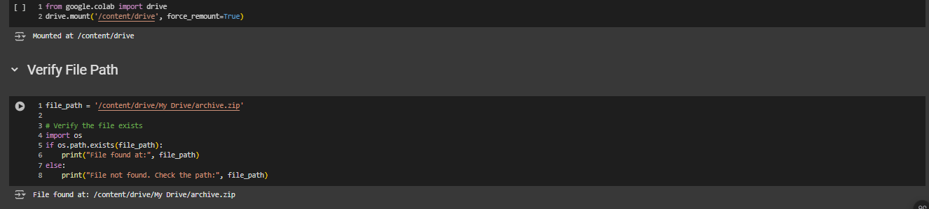

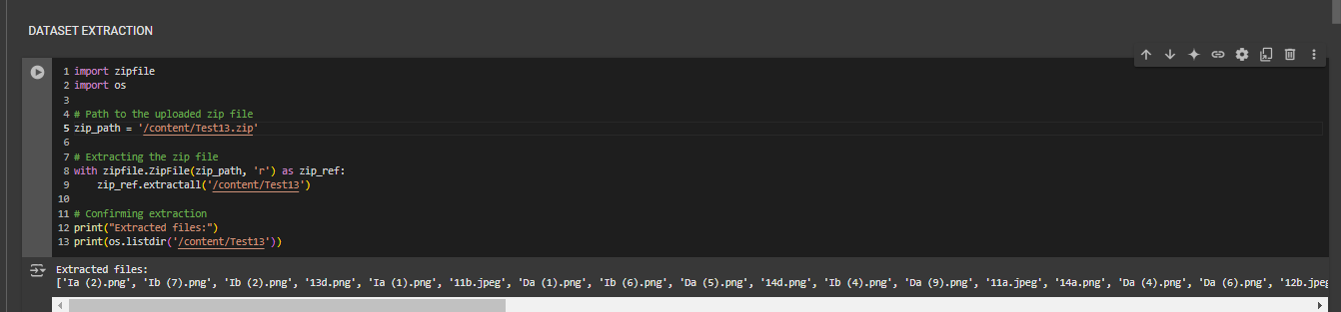

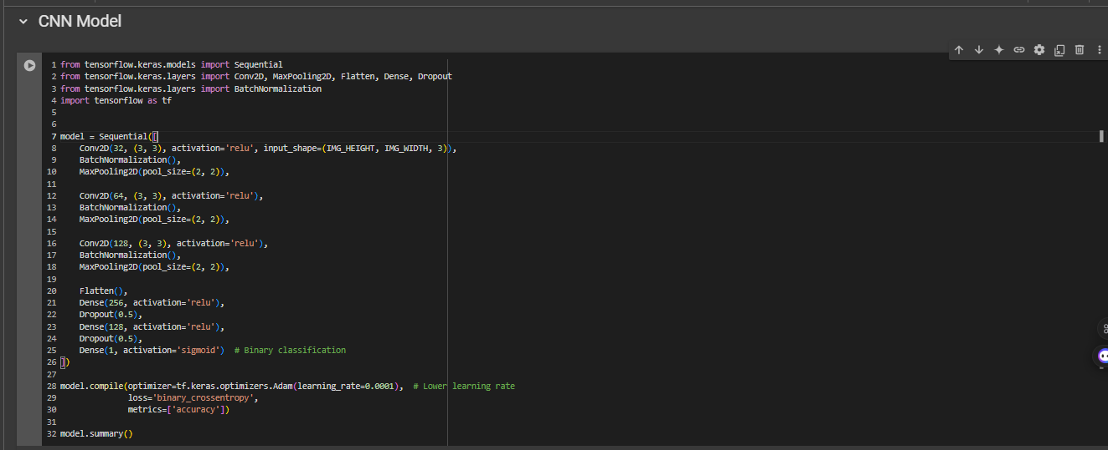

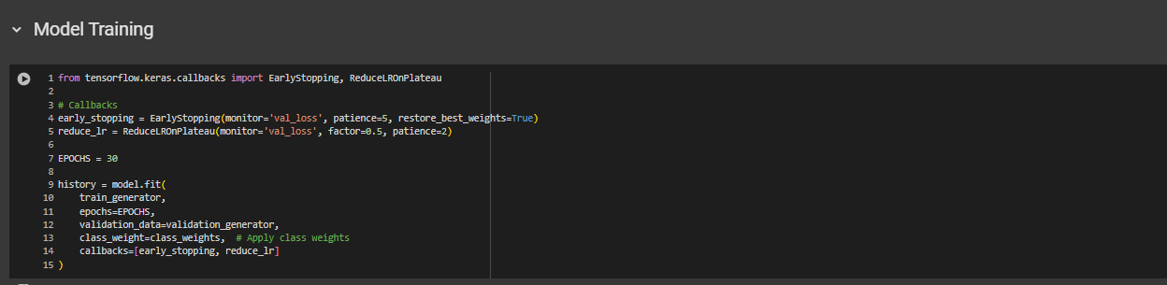



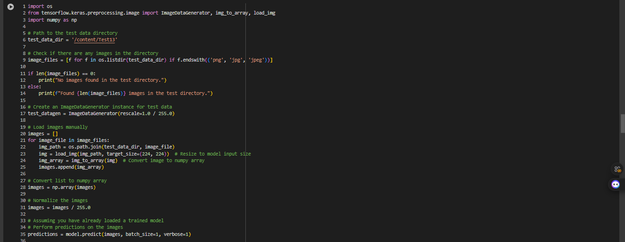

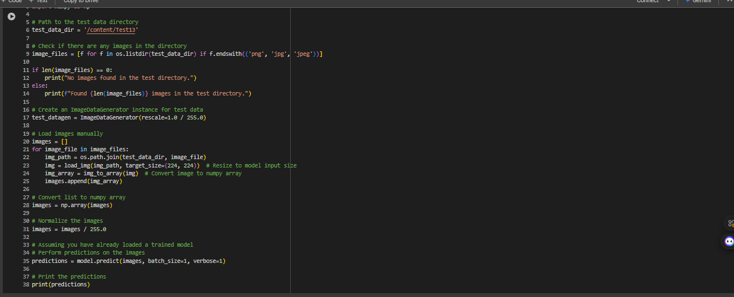

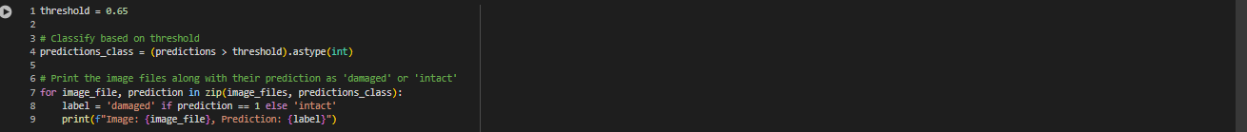

**APPENDIX-C**

**ENCLOSURES**

**1. Journal publication/Conference Paper Presented Certificates of all students.**

**2. Include certificate(s) of any Achievement/Award won in any project-related event.**

**3. Similarity Index / Plagiarism Check report clearly showing the Percentage (%). No need for a page-wise explanation.**

**4.** **Details of mapping the project with the Sustainable Development Goals (SDGs).**